WORK AND ENERGY

Definitions

Energy: a measure of a body’s (or system’s) ability to do work.

Work: is done when an applied force causes an object to move in the direction of the force.

The work done by a force on an object is given by:

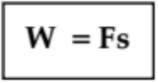

where W = the work done by the force (Joules - J).
F = the applied force (Newtons - N).
s = the displacement of the object in the direction of the applied
force (metres - m).

Examples

1. A box of mass 15.0 kg has a horizontal force of 2.00 x 102 N applied to it and it moves
4.50 m across a floor. What work has been done on the box?

W = Fs
= (2.00 x 10²)(4.50)
= 9.00 x 10² J

∴ Work done = 9.00 x 10² J

2. A car moving at 60.0 kmh⁻¹ due south has its brakes applied and it uniformly stops in
35.0 m. If the work done by the brakes is 8.87 x 10⁴ J, calculate the average force exerted
by the brakes.

W = Fs
=> F = W
s
= 8.87 x 10⁴
35.0
= 2.534 x 10³ N

∴ Average force exerted = 2.53 x 10³ N north
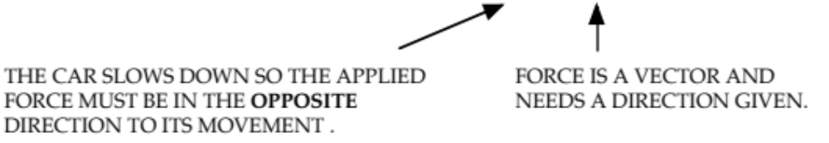

POTENTIAL AND KINETIC ENERGY

Potential Energy (E_{p})

This is the energy a body has due to the arrangement of its particles or due to its position above some level.

Something needs to happen to the system to release this potential energy.

Examples

Petrol - has stored E_{p} in its chemical bonds that is released as energy if it is burned.

An object at a height - they can potentially be pulled by gravity to the lowest level.

Gravitational Potential Energy

This is the energy possessed by a body due to its height above a given level.

Any object above a given "zero" level has the ability to release this energy as E_{k} as it falls to this "zero" level.

A child in a soapbox cart has E_{p} when stationary at the top of the hill. It is above the "zero" level.
At the bottom of the hill (the "zero" level), the cart has no E_{p} but has maximum E_{k}.
h

The amount of potential energy is given by:

E_{p} = mgh

where E_{p} = the potential energy of the body (J)
m = the mass of the body (kg)
g = the acceleration due to gravity (ms⁻²)
h = the height above the "zero" level (m)

Example

A 2.52 kg clock is sitting on a table, 1.52 m above the ground. Calculate the potential energy of the
clock.

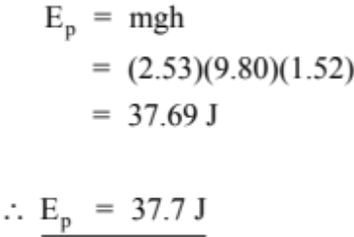

Kinetic Energy (E_{k})

This is the energy due to a body’s movement.

The kinetic energy of a body due to its movement is given by the equation:

E_{k} = ¹/₂ mv²

where : E_{k} = kinetic energy due to movement (J)
m = mass of the object (kg)
v = velocity of the body (ms⁻¹)

Example

A boy is riding a bike at 12.0 ms⁻¹. If the bike and boy combine weigh 67.8 kg, calculate the kinetic
energy of the system.

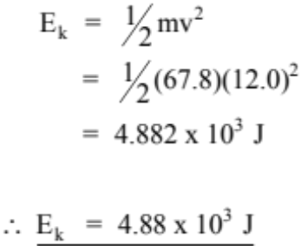

CONSERVATION OF MECHANICAL ENERGY

In all situations, energy must be conserved - it can be transformed from one form to another, but the total amount stays the same.

Example

Consider an object dropped from a height onto a hard surface.

The above situation describes a particular case where the total mechanical energy is conserved.

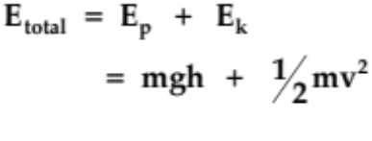

NOTE

In calculations, it will generally be considered that friction is not acting.

Example

A roller coaster of mass 3.70 x 10³ kg is moving at 8.00 ms⁻¹ at point A as shown below.

(a) Determine the total energy of the coaster at A.

(b) Calculate the speed achieved at point B.

(c) Does the coaster safely make it through the loop if the minimum speed to do so is 6.64 ms⁻¹?
Justify your answer by calculation.

(a) At point A:
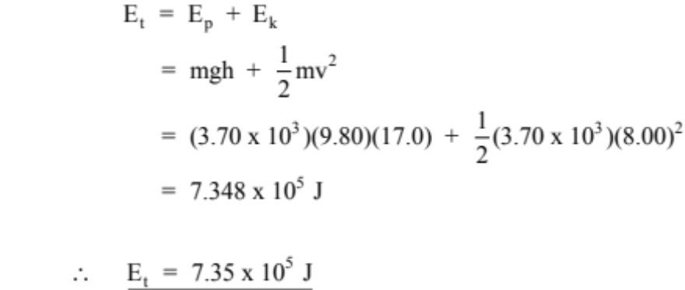

(b) At point B:
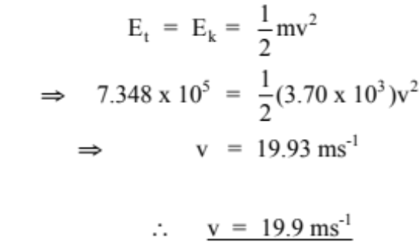

(c) At point C:
Remember to double the radius.
